Release Pipeline

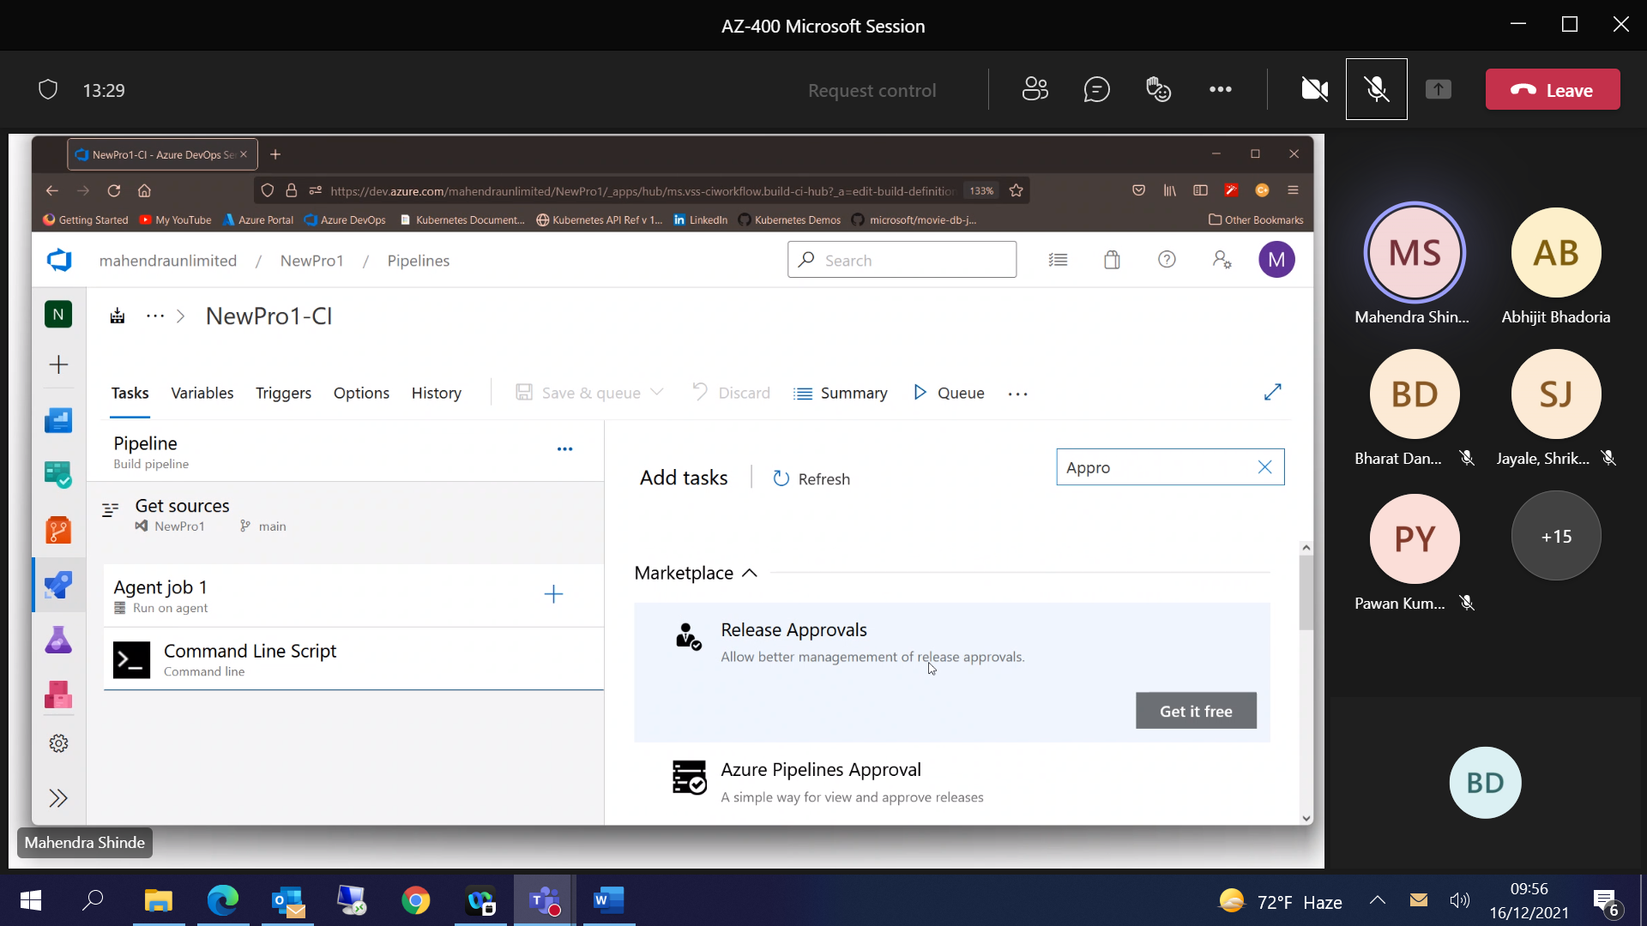

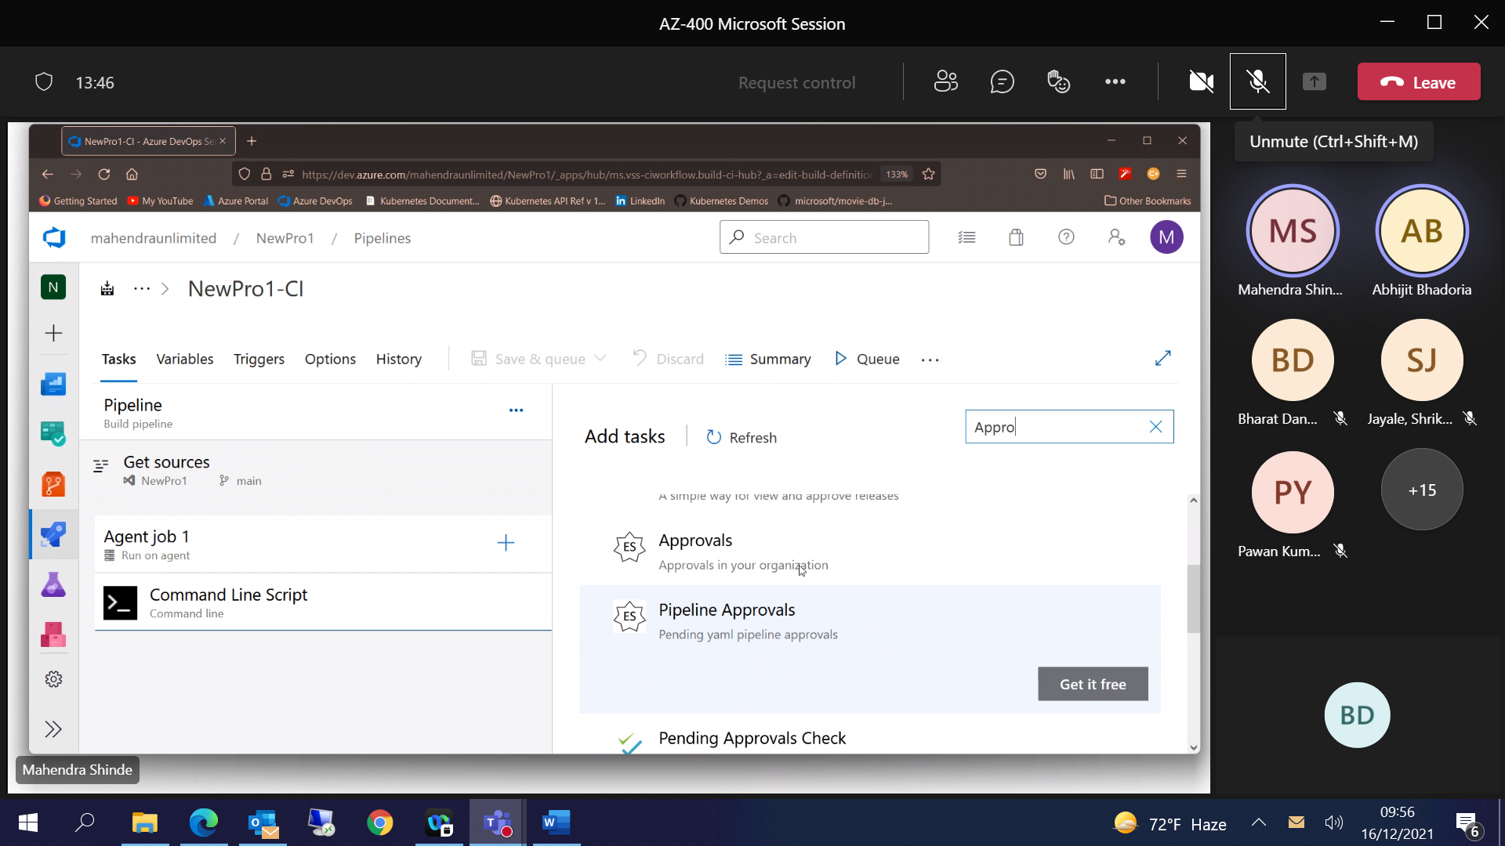

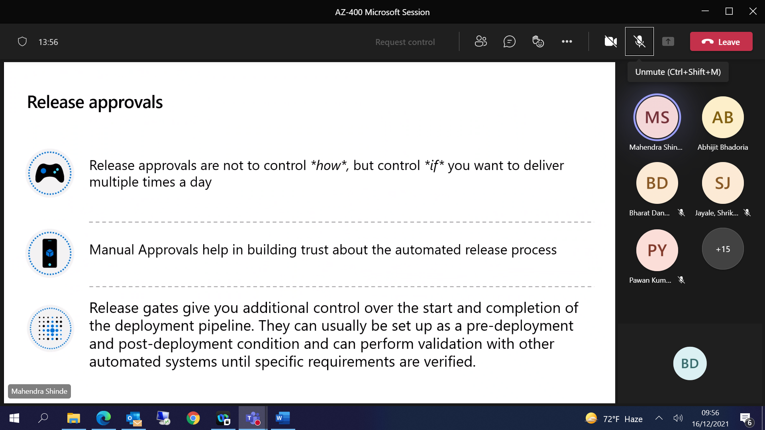

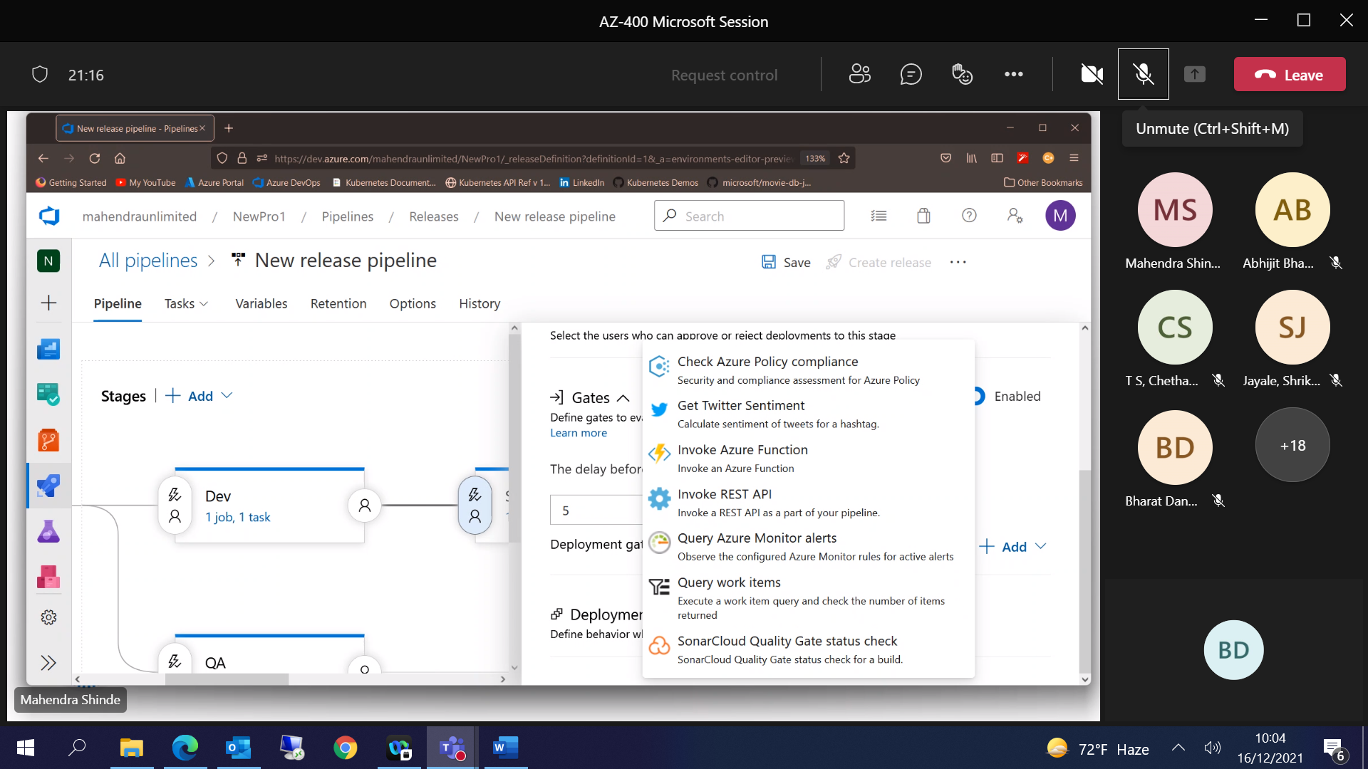

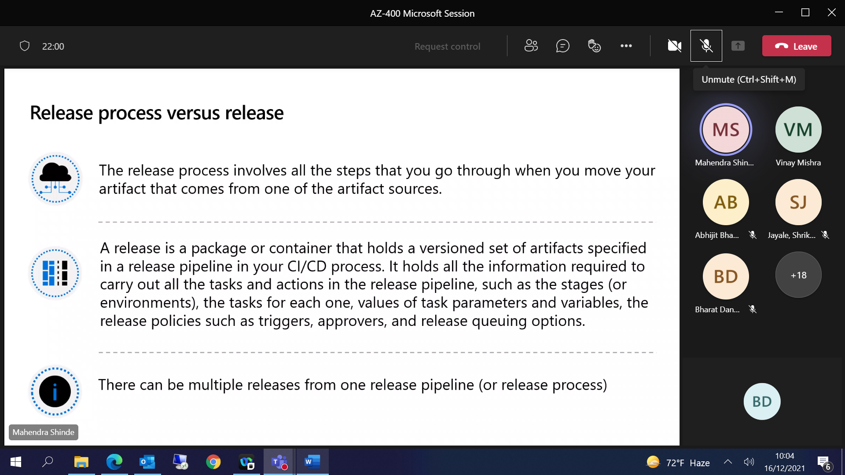

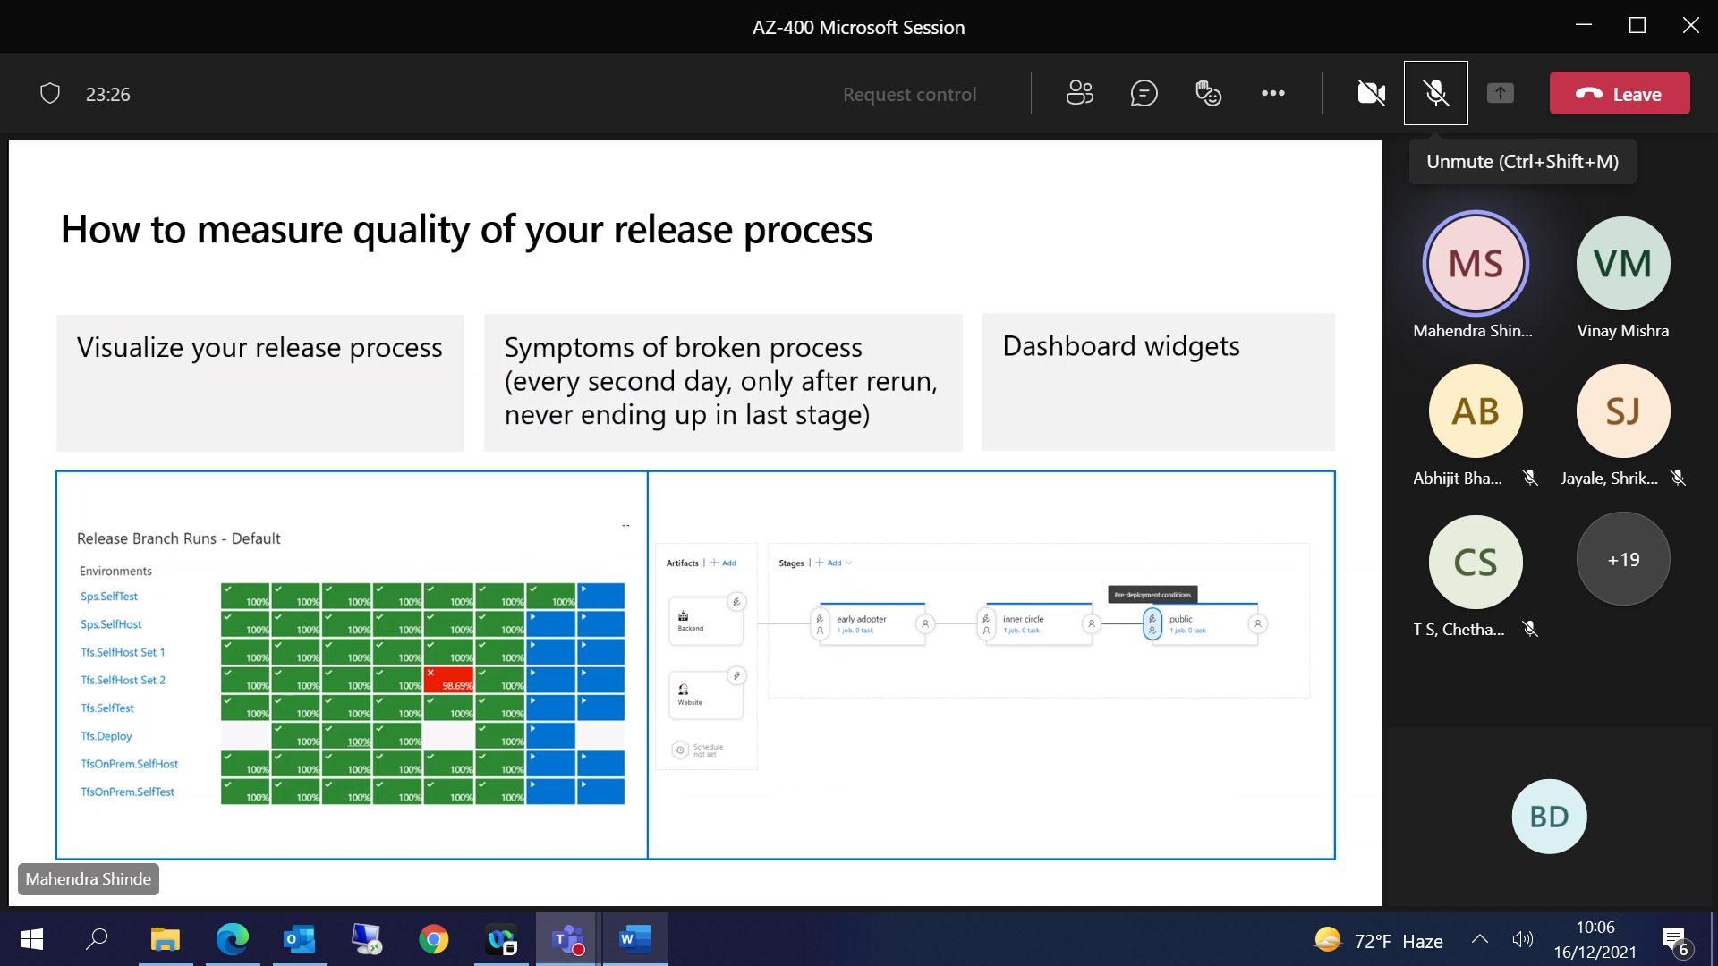

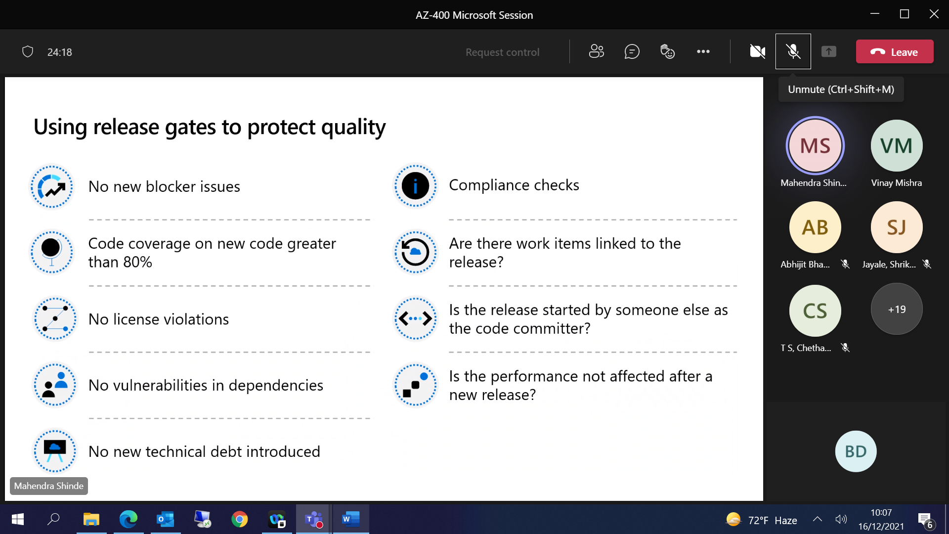

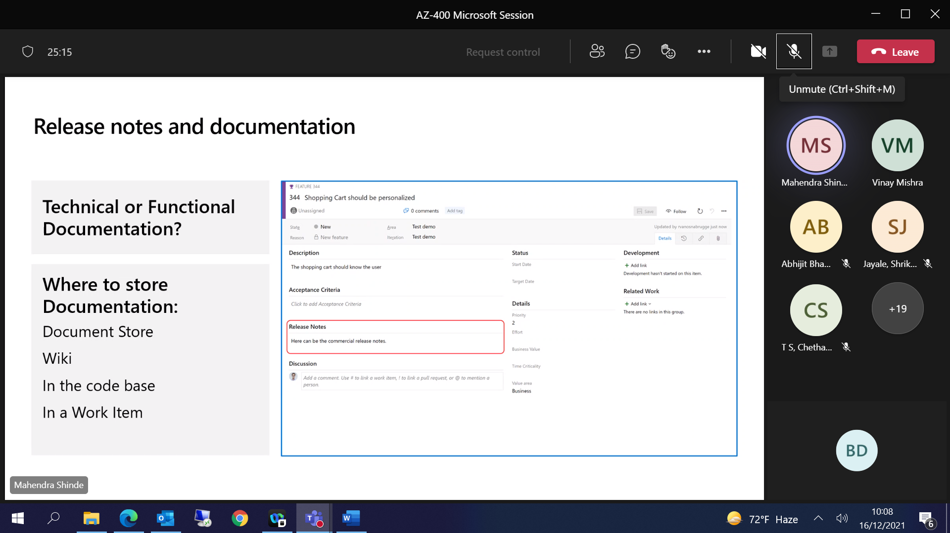

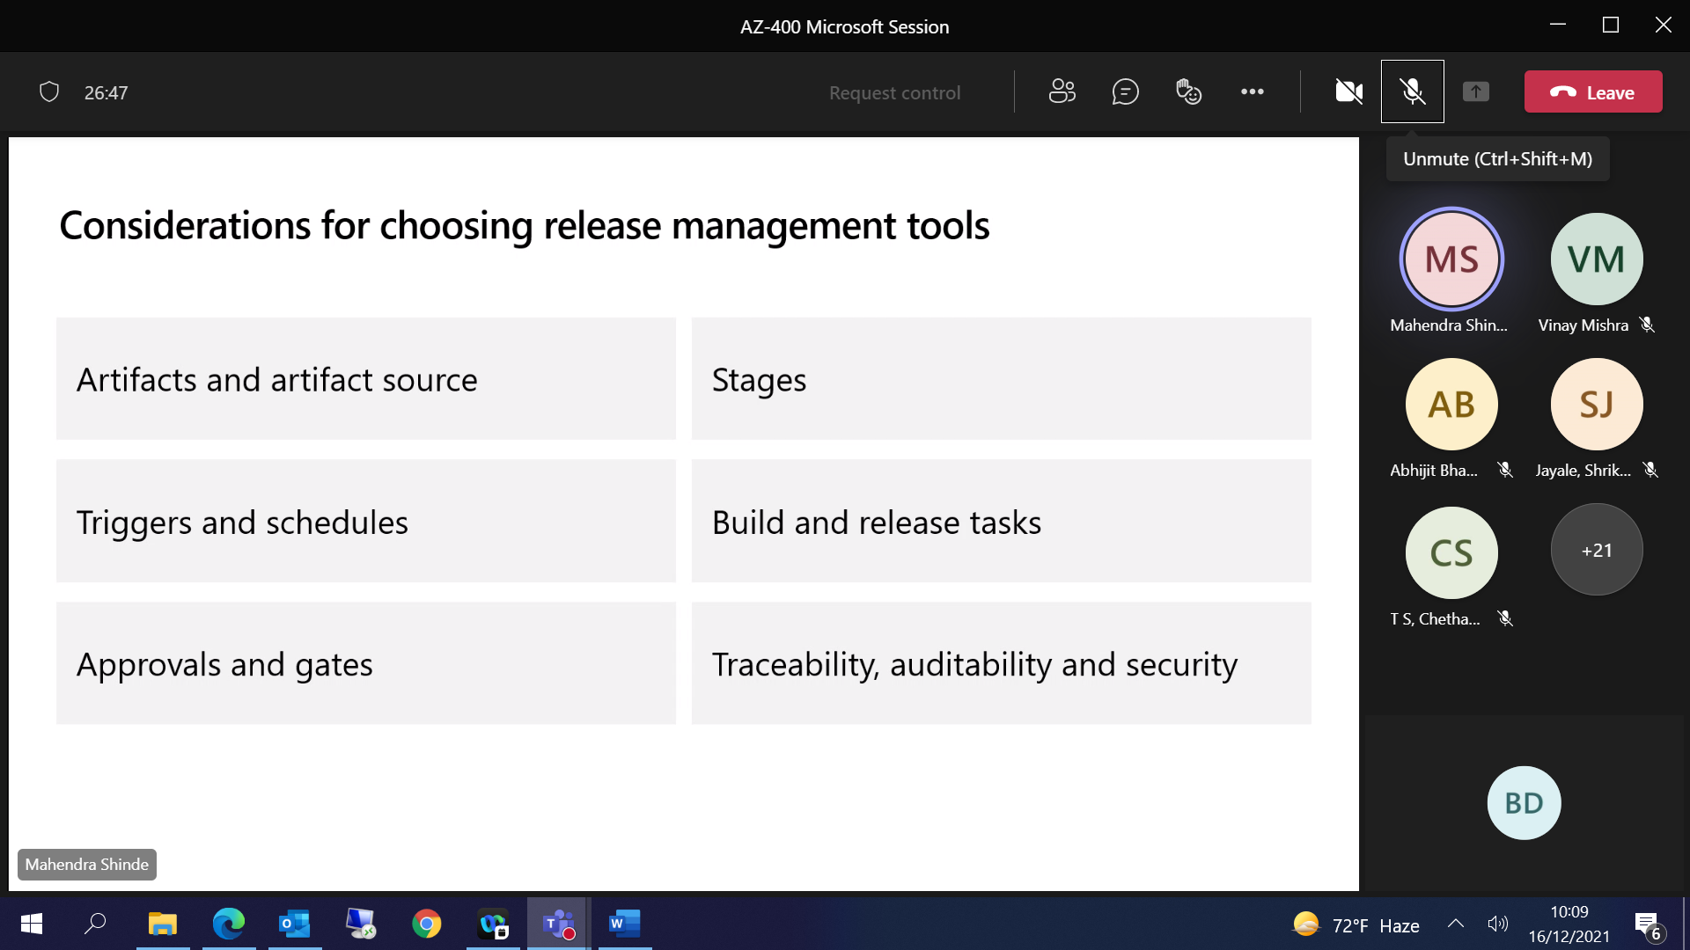

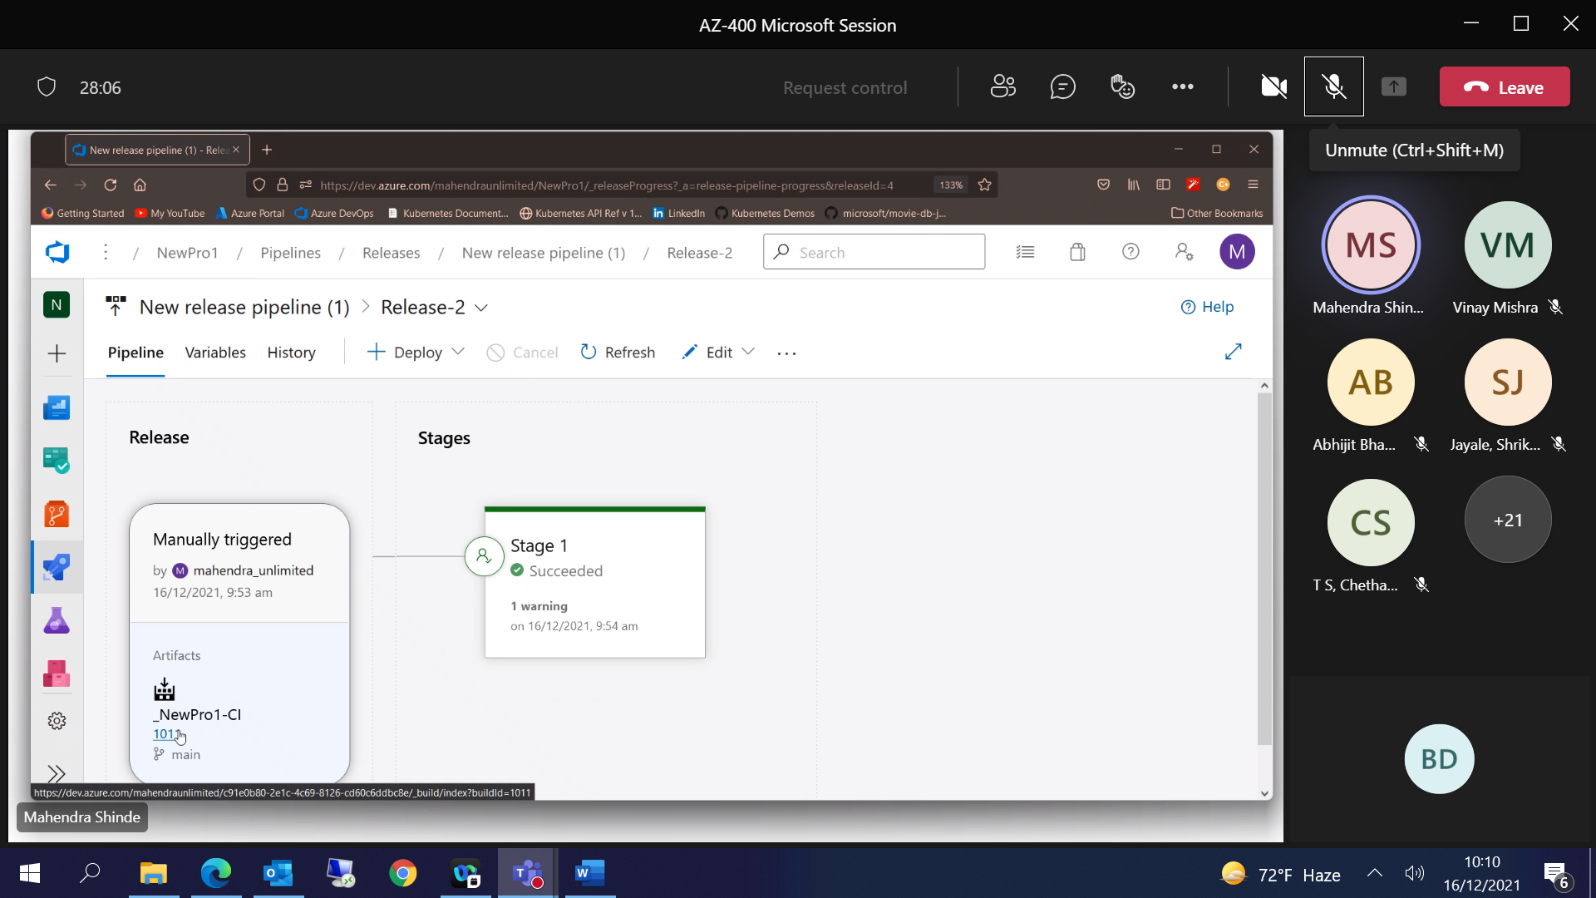

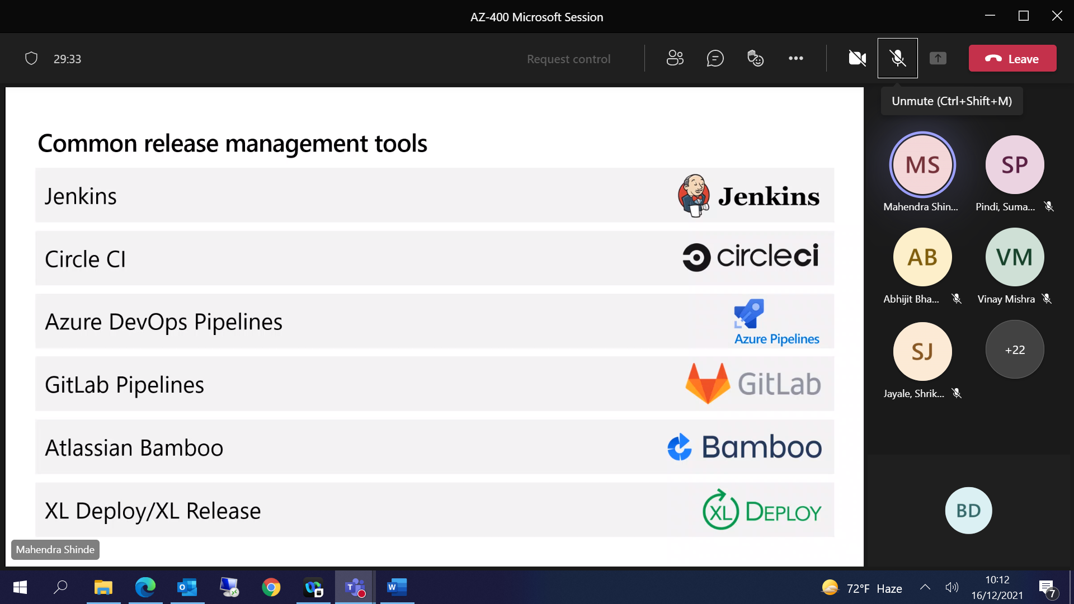

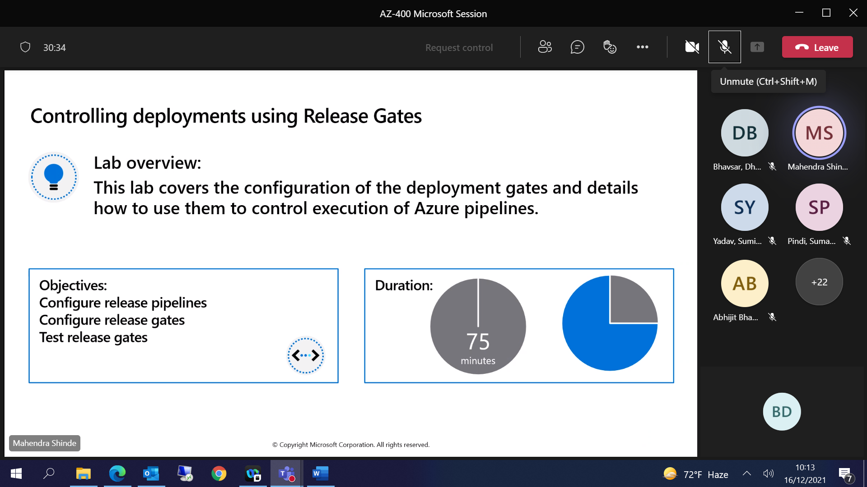

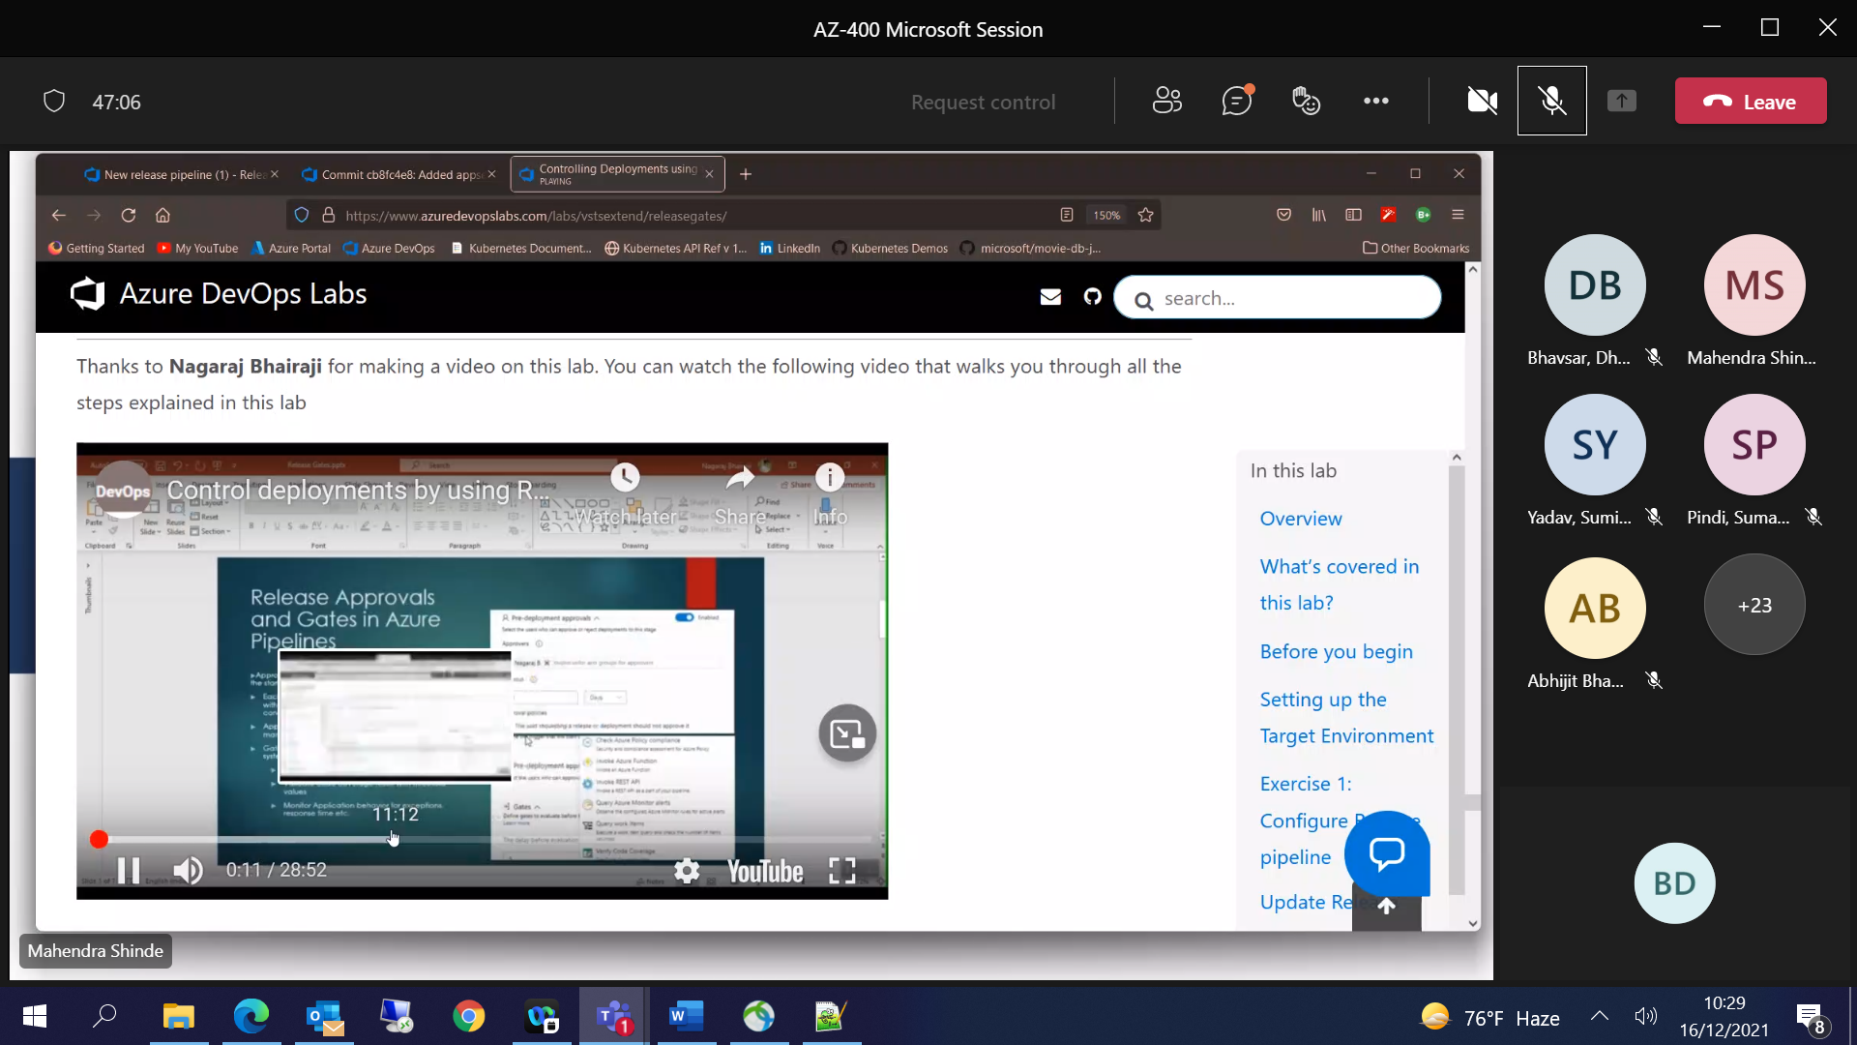

[10:19] Mahendra Shinde

<https://www.azuredevopslabs.com/labs/vstsextend/releasegates/>

like 1

Controlling Deployments using Release Gates

Check out the tutorial 'Controlling Deployments using Release Gates' and many more at https://aka.ms/devopslabs

[10:25] Mahendra Shinde

<https://docs.microsoft.com/en-us/azure/governance/policy/concepts/policy-for-kubernetes#policy-language>

like 1

Learn Azure Policy for Kubernetes - Azure Policy

Learn how Azure Policy uses Rego and Open Policy Agent to manage clusters running Kubernetes in Azure or on-premises.

[10:28] Bhavsar, Dhiraj (TSS)

<http://dbadailystuff.com/a-brief-introduction-to-yaml-in-powershell>

like 1

Josep - A Brief introduction to YAML in Powershell

A Brief introduction to YAML in Powershell - Missing an official YAML powershell module

[10:29] Bhavsar, Dhiraj (TSS)

<https://github.com/Phil-Factor/PSYaml>

laugh 1

Phil-Factor/PSYaml

A Powershell module to convert YAML documents to and from PowerShell objects

[11:17] Mahendra Shinde

Preparing "ENV" for "Deployment"  
1. Pre-prepared environment.  
- If Env is NOT READY, Release will FAIL  
+ Relatively Faster  
2. Prepare / Initialize the environment from Release pipeline.  
+ Prepare the environment  
+ Deploy application  
+ Run some tests  
+ Destroy it

A. Dev / QA Environment : Prepare ENV from Pipeline  
+ Cost Saving  
+ Re-Using the resources

B. Staging / Production Environment : Pre-provisioned environemnt  
+ Staging is sometimes used as an "Alternative" to production  
Green/Blue Deployment  
+ Staging MUST BE identical to PRODUCTION.